**Name:** Ria Rajan **Date:** November 8, 2021 **Lab section:** 007

**Show your work!!!**

**Acquire**

Week: 12 Date: 05/09/2021 Year: **2021** Data: What does 1GB of mobile data cost in every country?

**Source Article/Visualization:**

Visual Capitalist

<https://www.makeovermonday.co.uk/data/data-sets-2018/>

**Represent**

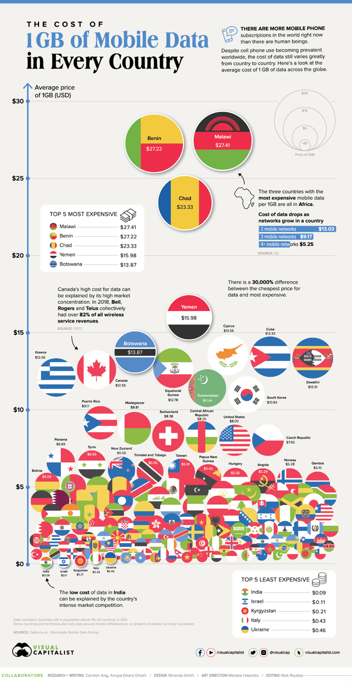

**Critique**

Critique the visualization: what do you like about it, dislike about it, what do you plan to do differently?

While this is a good visualization, the first thing I notice about it is that it’s very busy and kind of messy. This visualization is kind of in the form of a scatter plot in which it uses circles to represent countries and correlated these circles to a number on the vertical (y) axis. Additionally, the circles are filled in with their country flag. This brings in a lot of unnecessary color and makes in very hard to identify a country. Especially at the bottom where a lot of countries’ names are taken off the circles, so the viewer is left to identify the country by its flag. The visualization does include the top 5 least and most expensive countries on little boxes on the side which can help the viewer grasp some of the most important information. However, if the chart were in a different format, this would be unnecessary, and the viewer would be able to discern for themselves what countries are most expensive and what countries are least expensive. Additionally, the use of an axis on the side to display the cost at which each country is at as well as circle sizes is redundant and confusing. The visualization should stick to one method of communicating cost. I also think adding text on the visualization with extra facts adds to the messiness. This could be communicated outside of the visualization.

Based on your knowledge of the Periodic Table of Visualization Methods (discussed in class this week), discuss which one of the 6 categories does the visualization you provided in the Represent stage falls in. Identify the method most closely related to the visualization in the Represent Stage and discuss the characteristics: overview, detail, detail AND overview, divergent thinking, convergent thinking. Refer to Week 10 Readings to assist with categorizing the visualization.

This visualization most closely resembles a scatter plot. The circles on the visualization represent data points (or countries) and the cost of 1GB of mobile data in each country is on the y axis. A scatter plot is in the data visualization category. It is an overview visualization meaning the visualization can emphasize certain aspects of the data. It is also a structure visualization meaning it depicts a set of conceptual relationships. And it has convergent thinking which is a mode of critical thinking in which a person attempts to reduce complexity through analysis and synthesis.

**Mine**

What question(s) are you attempting to answer?

* In what countries is 1GB of mobile data the most expensive?
* In what countries is 1GB of mobile data the least expensive?
* Does cost correlate with country infrastructure?

**Filter**

**Show** (display, list, make it visible) the filtered data.

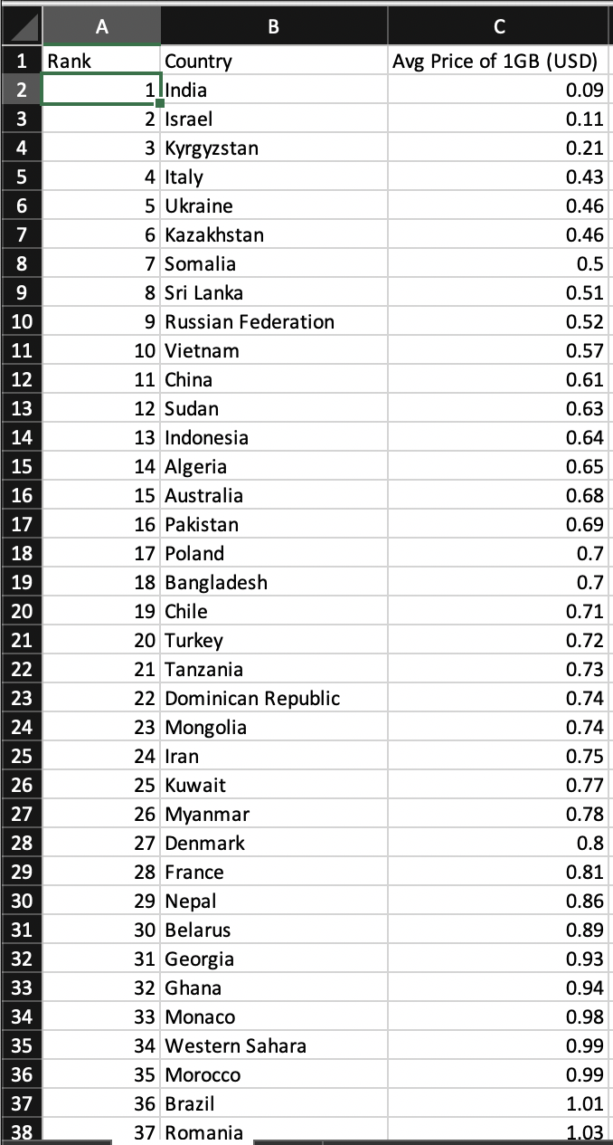

**Stakeholders**

* Who is your audience? What assumptions did you make? What visualization tool/software did you use?
* Since this information highlights the global technology gap, there is going to be a wide range of audiences. This information shows that the countries that usually have less infrastructure have higher costs of mobile data. So, the audience could be government officials in these countries to improve their infrastructure and lower the cost of mobile data. However, if the country already has poor infrastructure, the power to change this is not going to be in the hands of its government. So, another possible audience could be global humanitarian organizations such as the United Nations, the technology bank, and more which are all dedicated to closing the technology gap in LDC’s (Least developed countries). And another possible audience could be individual people around the world that want to take part in donating or helping to close the technology gap.
* An assumption I made is that countries higher in population have lower costs of 1GB of mobile data.

**What to submit:** This document in PDF format only (if you do not know how to do this, ask).

**Choose the best layout** for your makeover visualization: Portrait or Landscape, Remove the page of the layout that you DO NOT choose. No blank pages!

**NEW Sketch your Makeover**

In the space below, sketch out your ideas for refined visualization. You must use pen/pencil and paper to sketch out your idea, then take a photo of your sketch and include it in the space below.

**Refine (Makeover – Landscape view)**

Use an additional page if necessary. Remember, the purpose of visualization is “insight.” Take and include a screenshot of your visualization and include it below. Use Data Visualization Best Practices (see data visualization checklist). You MUST use more advanced chart types for your makeover. **Chart types that are not allowed: bar (single or stacked), pie, line charts, scatter plots, no tables.**

Figure Caption. The countries with a yellower shade have a less expensive cost of 1GB of mobile data and the countries with a redder shade have a more expensive cost of 1GB of mobile data.

**Resources**

Data Visualization Checklist:

<http://stephanieevergreen.com/wp-content/uploads/2016/10/DataVizChecklist_May2016.pdf>

How to give constructive criticism:

<https://personalexcellence.co/blog/constructive-criticism/>

Sample Makeovers

<https://www.makeovermonday.co.uk/gallery/>

**Grading Rubric**

|  |  |  |  |
| --- | --- | --- | --- |
| **Excellent**  **(11-15 pts)** | **Good**  **(6 -10 pts)** | **Fair**  **(2-5 pts)** | **Needs Improvement (0 - 1 pt)** |
| Meets **ALL** or most of these: Makeover is esthetically pleasing (color, perception), best practices followed (insightful), Correct dataset downloaded; provided an interesting point of view of the data; critiqued previous makeover, critique is constructive (indicates one thing that is done well, and one thing that could be done differently, what will be done to improve the visualization), assumptions (more than one) are listed. | Meets **MOST** of these: Makeover is esthetically pleasing (color, perception), best practices followed (insightful), Correct dataset downloaded; provided an interesting point of view of the data; critiqued previous makeover, critique is constructive (indicates one thing that is done well, and one thing that could be done differently, what will be done to improve the visualization), assumptions (more than one) are listed. | Consistently meets **SOME** of these: Makeover is esthetically pleasing (color, perception), best practices followed (insightful), Correct dataset downloaded; provided an interesting point of view of the data; critiqued previous makeover, critique is constructive (indicates one thing that is done well, and one thing that could be done differently, what will be done to improve the visualization), assumptions (more than one) are listed. | Little to no evidence of the understanding of the data visualization process.  Lackluster makeover or no makeover.  Little effort. |
| Sketch included: hand drawn [5 pts] | Sketch included, but was generated by computer [2 pts] | No sketch included. [0 pts] |  |
| Makeover Monday Assessment Completed  [5 pts] | Makeover Monday Assessment not completed [0 pts] |  |  |